Tutorial: How to register in Jira

- Keep in mind that this is a sample tutorial. Atlassian regularly changes some of the steps of the registration. We assume that if you are considering exploring the QA profession, you have the basic skills to download, install and register in various software programs, without any difficulties.

- Go to https://www.atlassian.com/software/jira

- Continue with email, google or Microsoft profile.

- Depending on the way you chose to register, there will be some additional verification that you need to perform.

- Now, that you have a profile, you have to create your site with Jira. Choose a meaningful name and follow
the naming rules: "Your site name must be 3 or more lowercase letters and/or numbers. Hyphens are ok if they’re in the middle."



- On the following screens, answer how you plan to use Jira. We chose "Software development" and "Track bugs", but actually, it doesn't matter what you will choose, since we'll create a bug tracking project later.
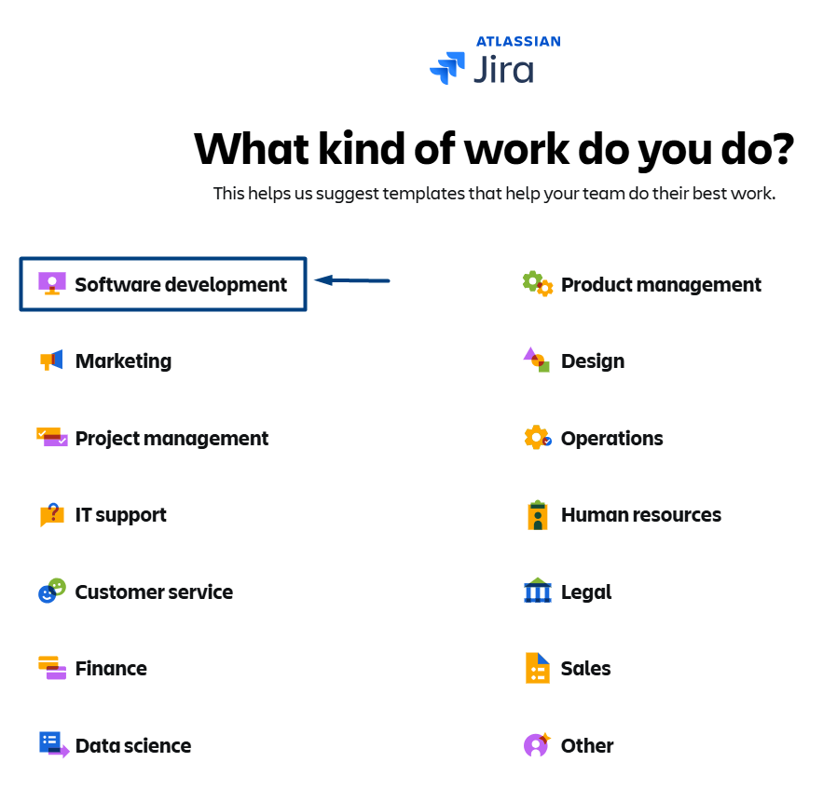

- Wait for the Welcome screen. Give some name to your project. This project also is irrelevant, since we will create the one that we need in a bit.

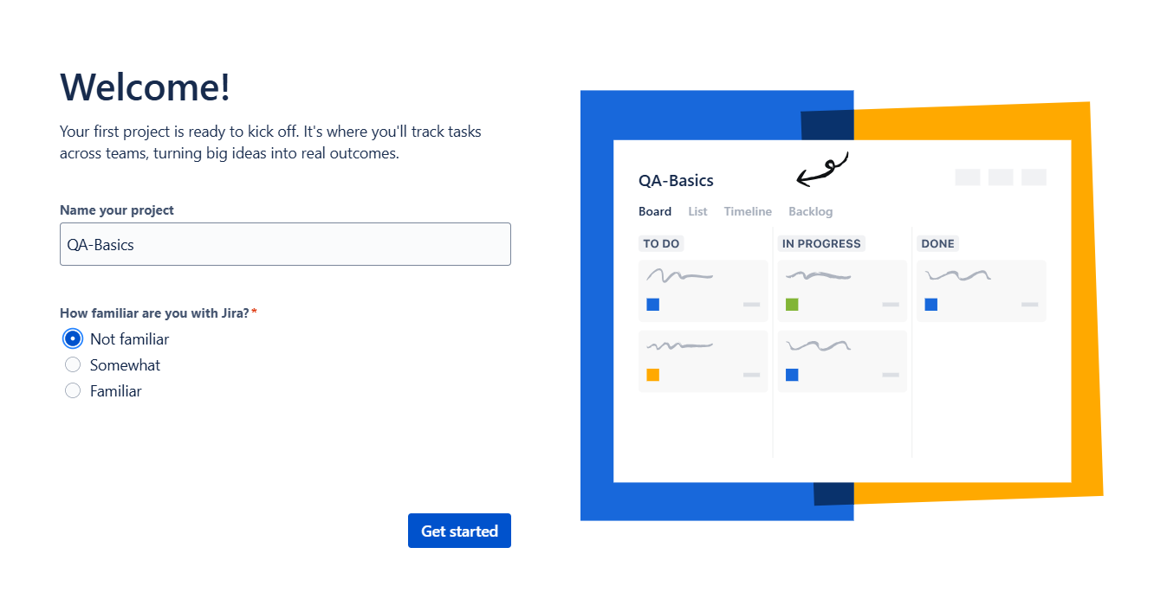
- From the following menu, choose "Projects" and then "Create project".
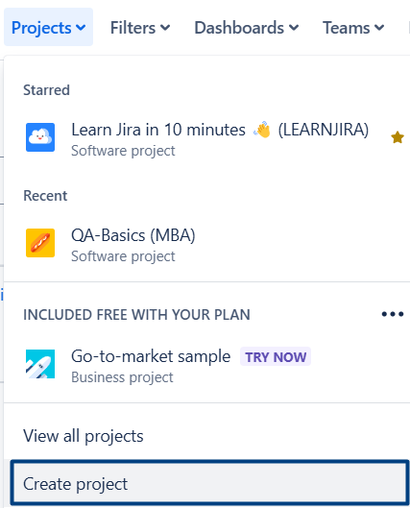

- From the suggested templates on the left, choose "Software Development".
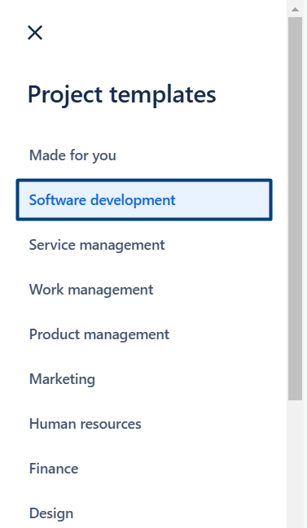
- Then scroll down through "Software development" templates and search and choose "Bug tracking".


- Click "Use template".
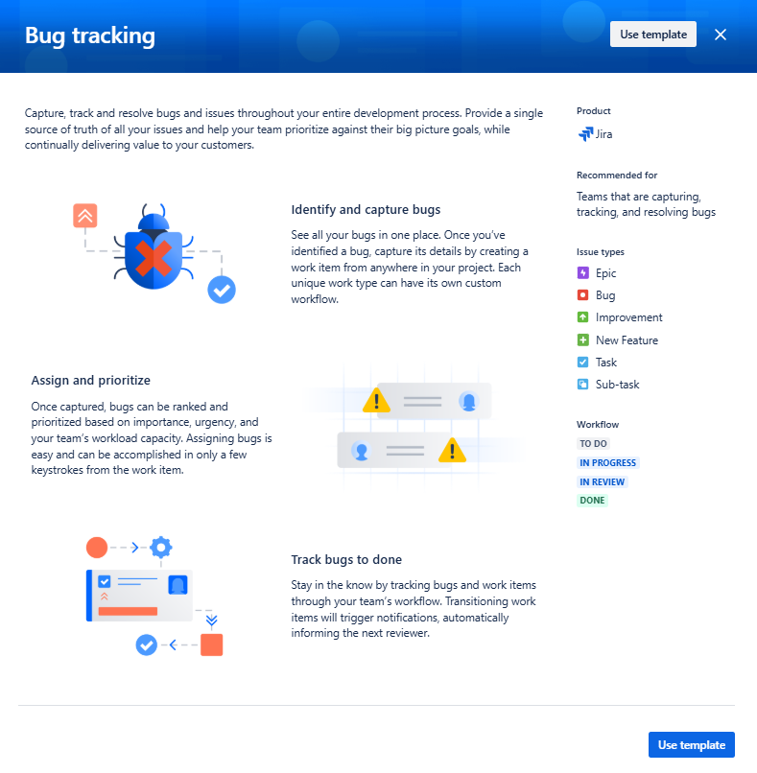
- Add project details.
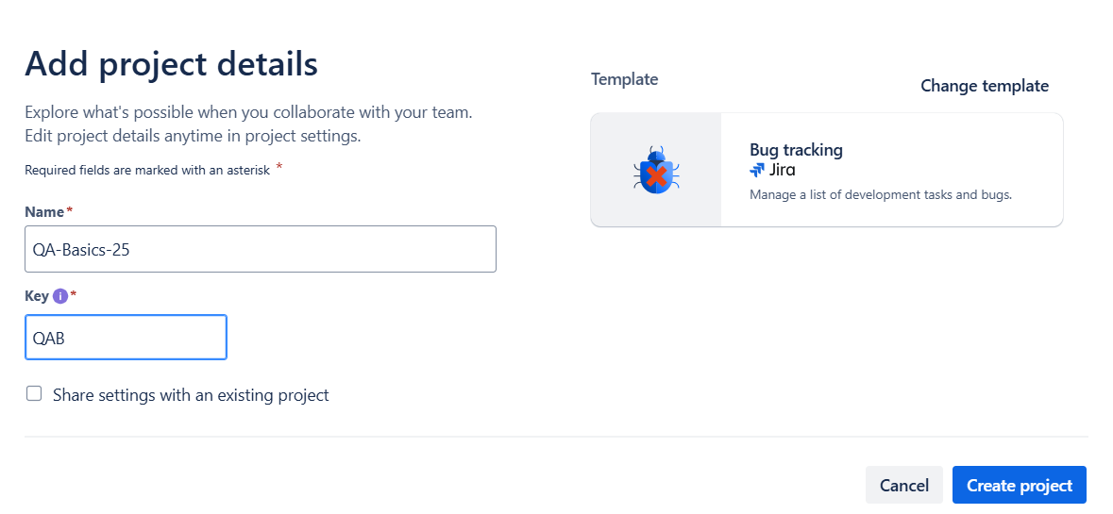
- And your "Bug Tracking" project is ready.
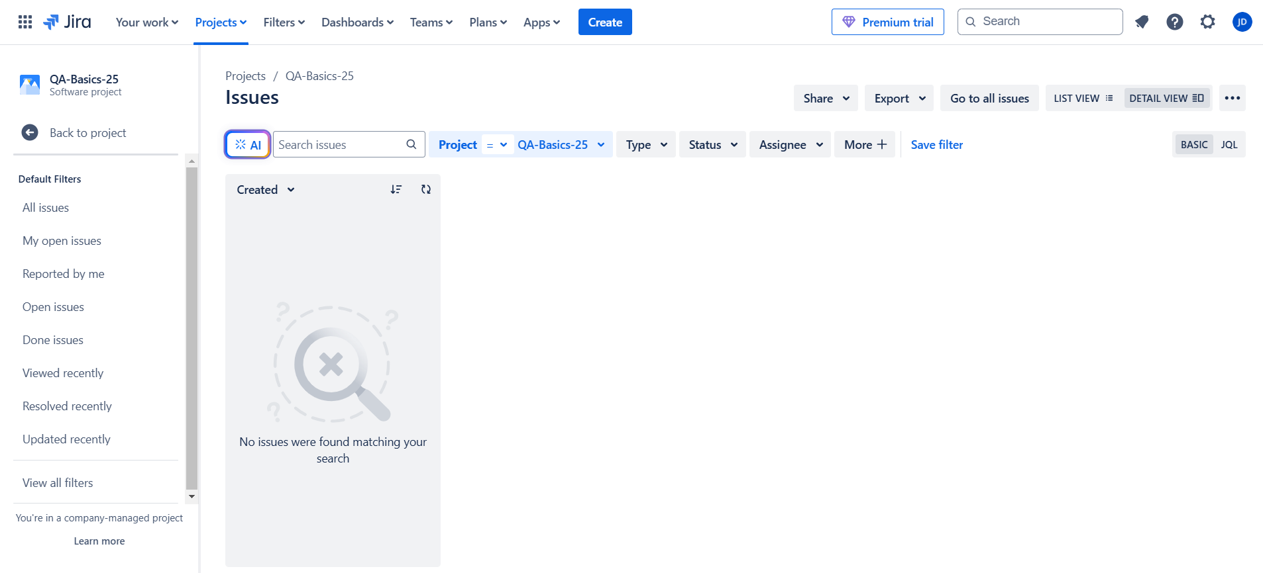
- Next time you visit https://www.atlassian.com/ and log in, click on the button and choose "Jira" to navigate to your project/s.
